Bandits dev diary

# Bandits come back

TODO : speak about the creation of this feature.

# Classical bandits

In the Vanilla, if you have no more money, some bandits (thieves, smugglers and highway robbers) can appear in your province. They can disappear when you will have new again money.  
It is a very poor feature.

We have changed the condition of apparition of the bandit.  
You can now have bandits when you manage badly your demesne (overthrow the demesne limit).  
They can disappear when you have money AND you respect the demesne limit.

We have also added another bandit group: the pirates for the coastal provinces.

But we have also do more.

# More powerful bandits

If the bandits stay in your province after some time, they cause many problems and you heard people talk about them.

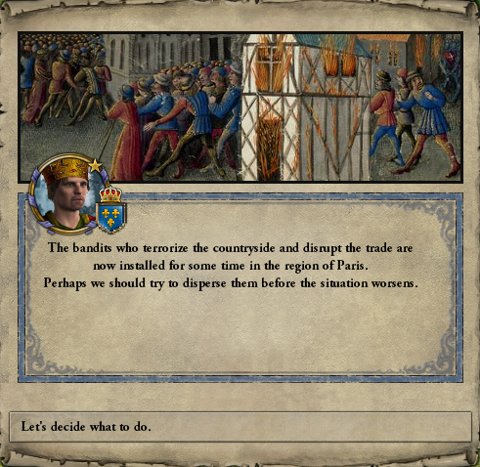

If you are not in war, you can convoke the Council (not related to Conclave DLC).

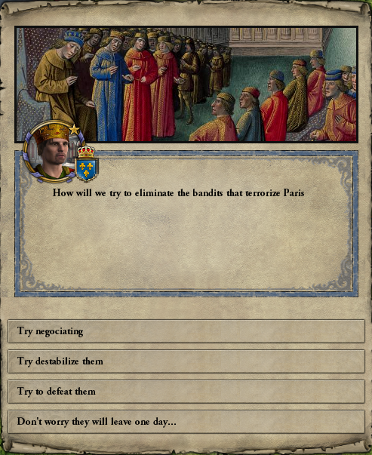

If your action is a success, the bandits leave your province but the province will need some time to be as productive as before the bandits.

If your action fails, the bandits will become more powerful.

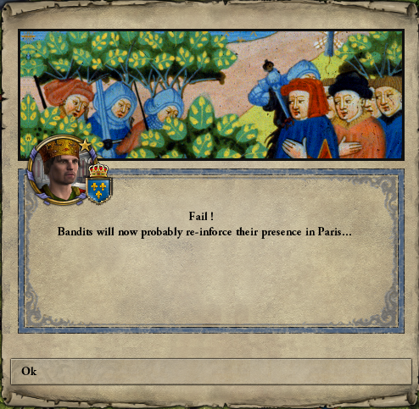

They will proliferate, it is not a good thing for the province economy after some time.

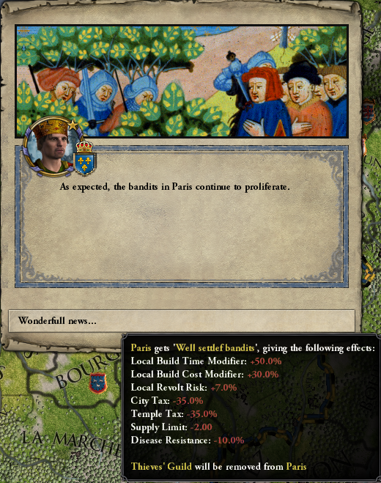

The bandits try to organize themselves.  
After some time, they can disappear or stay.

# The bandit life

Now our bandits are settled, they will cause other problems.

They can loot the holdings of the province.

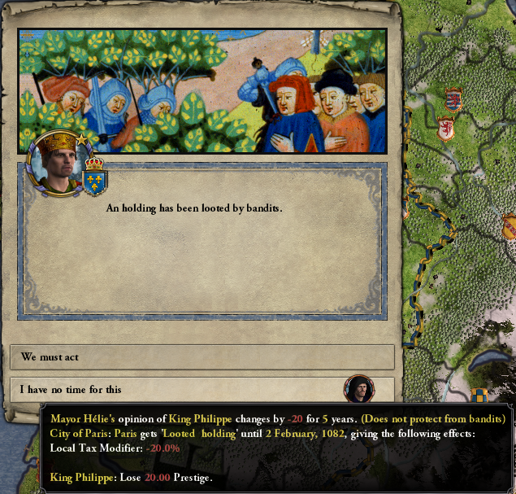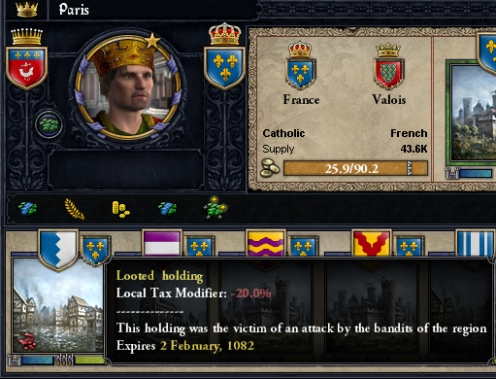

If you decide to act, you will convoke the council to fight the bandits.

Like if you would have a success at the beginning with the council action, the province will be some difficulties to become as profitable as before the bandit settling.

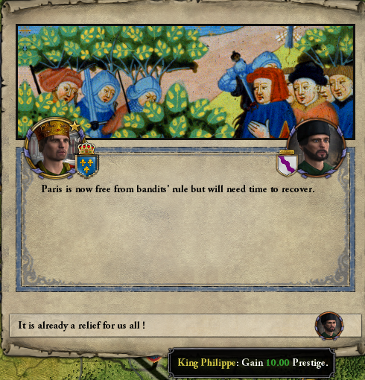

# What we want to do

* Add some actions to fight against the bandits. At the moment the bandits can go away after a looting.
* Add more flavor events.  
  At the moment there is an attack during hunting.  
  We will not reveal flavor events in the Dev Diary.